
HY/CSQP/1123/B 30-OCT-2023
HALF YEARLY EXAMINATION (2023-24)
Subject: Computer Science  Grade: XI |  |  | Max. Marks:70  Time:3 Hrs
Name: |  |  |  |  | Section: | Roll No:
General Instructions:
1. This question paper contains five sections, Section A to E.
2. All questions are compulsory.
3. Section A have 18 questions carrying 01 mark each.
4. Section B has 07 Very Short Answer type questions carrying 02 marks each.
5. Section C has 05 Short Answer type questions carrying 03 marks each.
6. Section D has 03 Long Answer type questions carrying 05 marks each.
7. Section E has 02 questions carrying 04 marks each.
8. All programming questions are to be answered using Python Language only.
 | SECTION A |  |  |  |  | 18
1. | Which of the following is an invalid statement? |  |  |  |  | 1
 | a. | abc=1,000,000 |  | b. | a, b, c= 100,200,300 | 1
 | c. | a b c=100 200 300 |  | d. | a=b=c=100 | 1
2. | What will be the value of the given expression?  3+3.00, 3**3.0 |  |  |  |  | 1
 | a. | (6.0, 27.0) |  | b. | (6.0, 9.0)
 | c. | [6.0, 27.0] |  | d. | [6.0, 9.0]
3. | If x = 12 and y = ‘12’, then what will be the output of the following code? print(x*2, y*2, sep="12") |  |  |  |  | 1
 | a. | 241224 |  | b. | 242412
 | c. | 122424 |  | d. | 122412
4. | Select the correct output of the code:  a = "foobar"  a = a.partition("o") |  |  |  |  | 1
 | a. | ["fo","","bar"] |  | b. | ["fo","oo","bar"] | 1
 | c. | ["fo","o","bar"] |  | d. | ["fo","o","obar"] | 1
5. | What will be the output of the following:  str = “Cricket World Cup in Australia”  str2 = str[:7] + ” “ + str[18:] + “.”  print(str2) |  |  |  |  | 1
6. | Give the output of the following:  a = "Year 2022 at All the best"  a = a.split('2')  print (a) |  |  |  |  | 1
7. | 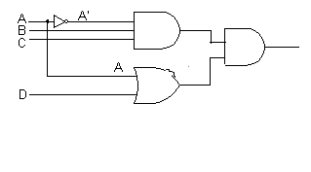  Give the logical expression for above circuit diagram |  |  |  |  | 1
8. | 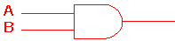  The above gate is known as |  |  |  |  | 1
 | a. | AND Gate |  | b. | NAND Gate
 | c. | OR Gate |  | d. | NOT Gate
9. | _____ gate results 1 for those input combinations that have odd number of 1’s |  |  |  |  | 1
 | a. | NOR |  | b. | XOR
 | c. | NAND |  | d. | All of the above
10. | ______ is a boot firmware that helps in starting the system. |  |  |  |  | 1
 | a. | ROM |  | b. | BIOS
 | c. | Chip |  | d. | RAM
11. | _______ is the breaking down a complex problem or system into smaller, more easily solved parts. |  |  |  |  | 1
 | a. | Decomposition |  | b. | Composition
 | c. | Debugging |  | d. | None of the above
12. | _______ is a rough description of program that does not require any programming language syntax or technology |  |  |  |  | 1
 | a. | Decision Tree |  | b. | Algorithm
 | c. | Flowchart |  | d. | Pseudocode
13. | 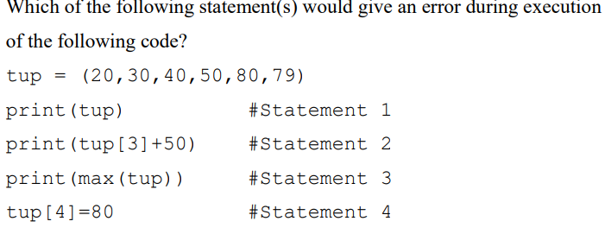 |  |  |  |  | 1
 | a. | Statement 1 |  | b. | Statement 2
 | c. | Statement 3 |  | d. | Statement 4
14. | What is the difference between append() and extend() method in lists? Support your answer with an example.
15. | What is the output when following code is executed ?  names = ['Freya', 'Mohak', 'Mahesh', 'Dwivedi']  print(names[-1][-1]) |  |  |  |  | 1
 | a. | i |  | b. | D
 | c. | F |  | d. | a
16. | What will be the output of the following code:  for i in range(1,10):  if i%4==0:  continue  print(i,end=” “) |  |  |  |  | 1
 | a. | 1 2 3 4 5 6 7 8 9 10 |  | b. | 0 1 2 4 5 7 8 10
 | c. | 1 2 4 5 7 8 10 |  | d. | 1 2 3 5 6 7 9
Q17 and 18 are ASSERTION AND REASONING based questions. Mark the correct choice as
(a) Both A and R are true, and R is the correct explanation for A.
(b) Both A and R are true, and R is not the correct explanation for A
(c) A is True but R is False
(d) A is false but R is True
17. | Assertion(A): List is an immutable data type.  Reasoning(R): When an attempt is made to update the value of an immutable variable, the old variable is destroyed, and a new variable is created by the same name in memory
18. | (A) In nested for loop, Break statement in the inner loop breaks the inner loop.  (R) Break statement is meant to break the loop it is running in.
 | SECTION B |  |  |  |  | 14
19. | Consider the statements given below and then give the output of below code.  pride="#G20 Presidency"  print(pride[-2:2:-2])  print(pride[::-1]) |  |  |  |  | 2
20. | What will be the output of the following code:  v=3  if v<8:  for j in range(v-1):  print("HI#")  else:  print("BYE") |  |  |  |  | 2
21. | The code given below accepts a number as an argument and returns the reverse number. Observe the following code carefully and rewrite it after removing all syntax and logical errors. Underline each correction made.  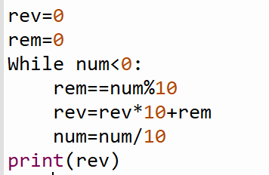 |  |  |  |  | 2
22. | Prepare truth table for the below expression:  F=XYZ’ + X’Y’Z |  |  |  |  | 2
23. | What will the following expressions be evaluated to in Python?  a) print(15.0 / 4 + (8 + 3.0))  b) print(True or False and not(True)) |  |  |  |  | 2
24. | a) Convert (110.11)₂ to decimal.  b) What is octal equivalent of (1110001101010.0110)₂ |  |  |  |  | 2
25. | What is an operating system? What is the need of operating system? (Any 4 points). |  |  |  |  | 2
 | SECTION C |  |  |  |  | 15
26. |  |  |  |  |  | 3
  Give the output of below code:
  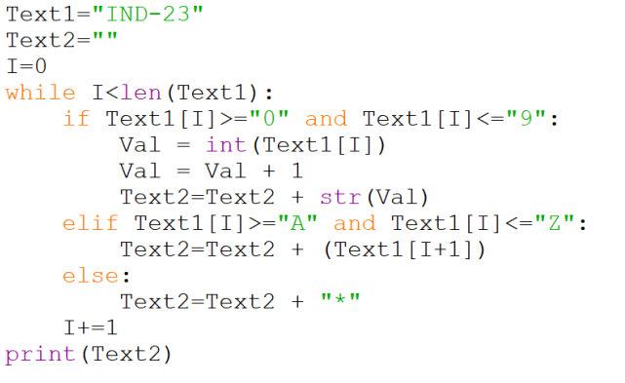
27. | - Convert (125715)₈ to its Binary equivalent.  - Covert from (445.2)₁₀ to octal  - Give full form of ASCII |  |  |  |  | 3
28. | Write a program, which accepts a list Arr of numbers and n is a numeric value by which all elements of the list are shifted to left.  Sample Input Data of the list Arr= [ 10,20,30,40,12,11], n=2  Output – [30, 40, 12, 11, 10, 20] |  |  |  |  | 3
29. | - Explain the difference between implicit and explicit type conversion stating the examples.  - State True or False “Variable declaration is implicit in Python.” |  |  |  |  | 2+1
30. | Give Output of the following  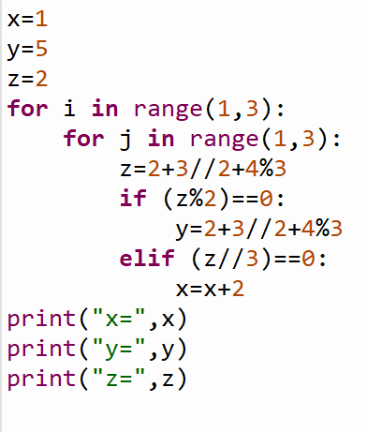 |  |  |  |  | 3
 | SECTION D |  |  |  |  | 15
31. | a) Give the output of the below code  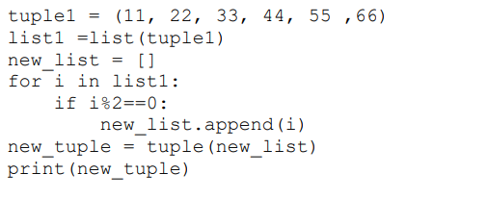  b)Predict the output of the Python code given below:  l1 = [10,15,16,18,20]  l1.remove(15)  l1.insert(1,30)  print (l1[::-2])  c) What is the difference between remove () and pop() method in lists? Support your answer with an example. |  |  |  |  | 1+2+2
32. | Write a menu driven program for the following options. The program should run as long as user wants.  - Accept a list of numbers from the user. Find the sum of numbers which are even.  - Accept a list of elements from user. Create another list which contains index of non-zero elements. |  |  |  |  | 5
33. | Do as follows:  - Write a for loop for printing below series.  10 7 4 1 -2 -5  - What is the value of the below expression.  A, b, c, d=1, 3, 5, 2  print(a + b > c **d or a * b < c * d)  - Given a String s=”PythonIsFun”. If n=int(len(s)/2), then what will be  the output of the following statements:  >>>print(s[:n])  >>>print(s[n:])  - Consider the list given below  L=[13,5,6]  Write the statement to insert 25 at index 1. |  |  |  |  | 1+1+2+1
 | SECTION E
34. | a) What is the difference between lists and tuple?  b) WAPS to generate the first 8 numbers of Fibonacci series. Save your result in the form of tuple.( 0 1 1 2 3 5 8 13) |  |  |  |  | 2+2
35. | WAPS that input words of strings in a tuple and encrypts the string as per PIG LATIN.  PIG LATIN is a word formed by taking first letter of the string and then moving it to the end and then joining with ‘ay’.  Example  If the string is:  (‘The’,’Quick’,’Brown’,’Fox’)  After translating the string would be  (‘hetay’,’uickqay’,rownbay’,oxfay’) |  |  |  |  | 4
***

